

Software Engineering Department  
ORT Braude College

Capstone Project Phase A – 61998

25-1-D-10

**Mathio Bros.**

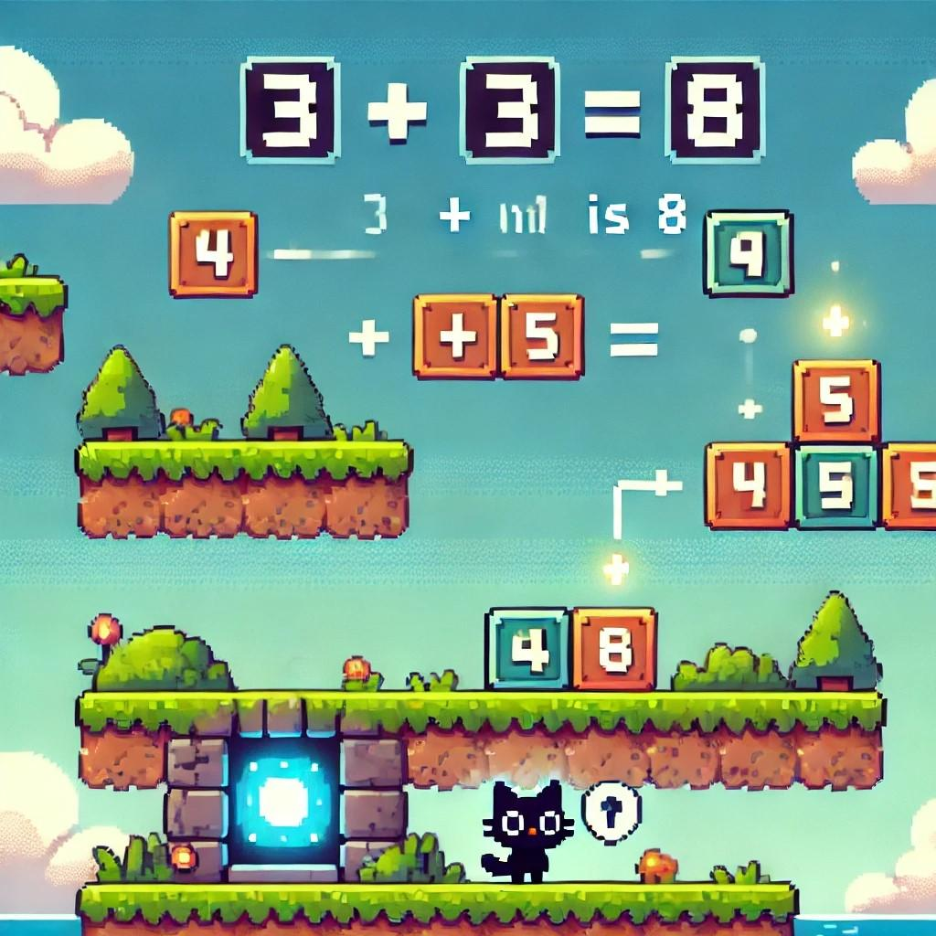

Maayan Etzioni: [Maayan.Etzioni@e.braude.ac.il](mailto:Maayan.Etzioni@e.braude.ac.il) 211567342

Lior Panikashvili: [Lior.Panikashvili@e.braude.ac.il](mailto:Lior.Panikashvili@e.braude.ac.il) 319003943

Supervisor: Moshe Sulamy [moshesu@braude.ac.il](mailto:moshesu@braude.ac.il)

Table of Contents

1. Introduction 4

2. Related Work 5

3. Background 7

3.1 Importance of Mathematical Understanding 7

3.2 The Benefits of Gamified Math Learning 8

4. Expected Achievements 9

4.1 Outcomes: 9

4.2 Unique Features: 11

5. The Process 12

5.1 Research – Math Education: 12

5.2 Research – Game Design and Mechanics: 12

5.3 Development Methodology: 12

5.4 Development – Unity Game Engine and Web Dashboard: 13

6. Product 15

6.1 Requirements 15

6.2 Architecture Overview 16

6.3 Simulation Flow 17

6.4 Data Storing and Handling 22

6.5 Diagrams 23

6.6 Web Application 26

Web App Pages 26

7. Verification and Evaluation 30

7.1 Evaluation 30

7.2 Verification 31

Test Plan 32

7.3 Testing Frameworks 34

8. References 35

## Abstract

This project aims to develop a multiplayer math teaching game called "Mathio Bros." designed to enhance children's mathematical skills in an engaging and interactive environment. The game, resembling the popular Mario Bros. platform, the game will allow students to solve math problems while navigating through various levels and challenges. It will include multiplayer capabilities for collaborative learning and a teacher dashboard that tracks student progress. By combining entertainment and education, the project hopes to improve math learning outcomes and foster a love for learning among children.

## 1. Introduction

Education, especially in subjects like mathematics, is critical for the development of children's problem-solving and analytical skills. However, many students find math intimidating, leading to disengagement and poor performance. Traditional teaching methods, while effective, sometimes fail to capture the interest of young learners. This project, "Mathio Bros.," seeks to bridge this gap by combining gamification with education. By creating an interactive platform where students can solve math problems while playing a fun, multiplayer game, we aim to create a learning experience that is both enjoyable and educational. The project also includes a teacher dashboard, which helps instructors monitor student progress and tailor lessons to individual needs.

One of the key aspects of the "Mathio Bros." project is the careful design of a gradual difficulty progression. In traditional learning settings, students are often introduced to complex concepts too quickly, which can lead to confusion and frustration. By gradually increasing the difficulty of math problems according to the individual learner’s pace, we aim to prevent students from becoming overwhelmed. This gradual increase ensures that students experience a sense of accomplishment as they tackle progressively harder challenges. Moreover, it allows them to build a solid foundation in basic concepts before moving on to more advanced material. This approach fosters confidence, helping students understand that mastering math is a process that takes time, practice, and perseverance.[1]

Equally important to the success of this platform is the role of teachers in guiding students through their learning journey. While gamification can make learning engaging, it is the supervision and guidance of educators that ensure the effectiveness of the educational process. The teacher dashboard within the "Mathio Bros." platform is designed to provide instructors with real-time insights into student performance, enabling them to identify areas where students may need additional support. With this data, teachers can customize lessons to address individual challenges, offering personalized interventions and feedback that will help students stay on track. Teachers can monitor the progress of each student, celebrating their successes while also stepping in when additional guidance is needed to reinforce learning. By maintaining a balance of autonomy for students and supervision from teachers, we hope to create an environment where children feel supported and encouraged, leading to improved outcomes in their mathematical abilities.[2]

Additionally, teachers can use the platform's data not only to improve student outcomes but also to promote a sense of healthy competition and collaboration. The multiplayer aspect of "Mathio Bros." fosters teamwork and communication among students, allowing them to learn from one another as they solve problems together. With proper guidance, this collaborative approach can motivate students to approach math with a sense of camaraderie, transforming it from a daunting subject into an enjoyable challenge. The blend of gamified learning and teacher support aims to create an educational experience that both motivates and nurtures students, preparing them for success in mathematics and beyond.[3]

## 2. Related Work

There are a few websites for math teaching games for children:

Here are a few examples:

Cool Math Games[1]

Math-tagged games hosted on itch.io[2]

Mathsframe[3]

These existing educational websites offer games focused on elementary mathematical concepts such as addition, subtraction, multiplication, and division. In contrast, our game will provide a significantly more complex and engaging experience, incorporating multiplayer functionality and robust supervision tools for instructors, teachers, and parents. Also a similar but single-player and 3d math teaching game: The Ultimate Math Teaching Game [4]

In [1] the researchers investigated the effects of the Gradual Release of Responsibility Instructional Model (GRRIM) on Grade 9 students' mathematics performance and self-efficacy. Using a quasi-experimental design, the study compared a group receiving GRRIM instruction with a control group receiving traditional instruction. While pre-test scores were low for both groups, the GRRIM group showed a significantly higher post-test score, indicating improved performance after the intervention. However, no significant difference was found in retention test scores between the two groups. Regarding self-efficacy, both groups initially demonstrated moderately low levels, and no significant differences were observed between the GRRIM and non-GRRIM groups across the four self-efficacy sources (mastery experiences, vicarious experiences, verbal-social persuasion, and physiological and emotional arousal). The study concludes that GRRIM can be effective in improving immediate mathematics performance but may not have a lasting impact on retention or self-efficacy as measured in this study. The author recommends further research and suggests incorporating cooperative learning and varied teaching strategies within the GRRIM framework.

This chapter [2] emphasizes the often-overlooked role of teachers in successful game-based learning (GBL) implementation. Through an examination of existing literature and three empirical studies, the authors argue that teachers are not simply facilitators of gameplay but crucial "engineers of playful frames," bridging the gap between the game world and the curriculum. The studies revealed that teachers often require significant support, including training in-game mechanics, game literacy, and pedagogical strategies for integrating games effectively. Notably, even when teacher roles were considered in game design (as in the *Homicide* study), additional training was still necessary for successful implementation. Other challenges highlighted include technical difficulties, the need for curriculum adaptation, and the importance of maintaining the "illusion" of the game world to avoid disrupting student engagement. The authors advocate for a shift in perspective, viewing GBL not just as a tool to motivate students but also as an opportunity for teacher empowerment and professional development. They propose a participatory design model that involves teachers in the design process of GBL applications and advocate for integrating game design thinking and game literacy into teacher education programs. This approach aims to foster a "culture of participation" where teachers become active agents in shaping the learning environment and effectively leverage the potential of digital games for educational purposes.

This paper [3] provides a systematic review of research on cooperative learning in mathematics education, with a specific focus on the Student Teams-Achievement Divisions (STAD) model. Examining 12 studies published between 2006 and 2016, the authors found consistent evidence supporting the positive impact of cooperative learning, particularly STAD, on various student outcomes. These benefits include improved mathematics performance, more positive attitudes toward mathematics, increased student confidence in their mathematical abilities, and enhanced positive interactions among students. The review highlights that STAD, with its structured approach and emphasis on individual accountability within team success, is particularly well-suited for mathematics instruction. While acknowledging potential challenges in implementation, such as the need for teacher training and preparation, the authors conclude that cooperative learning, especially through the STAD model, offers a valuable alternative to traditional teaching methods and should be more widely adopted in mathematics classrooms to foster both cognitive and affective development.

## 3. Background

This section lays the groundwork for the importance of our educational game by highlighting the benefits of mathematical proficiency and the limitations of traditional methods. It then explores the advantages of game-based learning and collaborative learning, both of which our game will incorporate.

### 3.1 Importance of Mathematical Understanding

Mathematical understanding is fundamental to navigating the complexities of the modern world and plays a crucial role in individual development.[5] Beyond its practical applications in everyday life, mathematics education cultivates essential cognitive skills that extend far beyond numerical computation.[6] A strong foundation in mathematics fosters logical reasoning, critical thinking, and problem-solving abilities, empowering individuals to analyze information, identify patterns, and make informed decisions.[4] These skills are not only vital for success in STEM fields but are also transferable to various disciplines and real-world situations.[7] Early mathematical experiences lay the groundwork for future academic success, influencing performance not only in subsequent math courses but also in subjects like science, technology, and even literacy.[8] Moreover, developing a positive attitude towards mathematics from an early age can mitigate math anxiety, fostering confidence and a willingness to engage with challenging problems, ultimately contributing to greater academic and personal achievement.[5]

### 3.2 The Benefits of Gamified Math Learning

Learning mathematics in a gaming or fun environment offers numerous advantages that traditional methods often struggle to replicate. By embedding mathematical concepts within engaging gameplay, learners experience a shift from passive absorption to active participation, leading to deeper understanding and improved retention.[6] This active engagement fosters deeper understanding and improved retention of mathematical principles. Games provide a safe and motivating space for experimentation and exploration, where learners can test hypotheses, make mistakes without fear of judgment, and learn from those errors in a constructive way.[7] The inherent feedback mechanisms within games offer immediate and personalized responses to learner actions, allowing for timely adjustments and reinforcing correct understanding.[8] Furthermore, the incorporation of game mechanics like points, badges, and leaderboards can enhance motivation, encourage perseverance, and foster a sense of accomplishment, transforming the often-perceived chore of math practice into an enjoyable and rewarding experience.[9] This positive association with mathematics can, in turn, reduce math anxiety and cultivate a more confident and resilient approach to problem-solving.[10]

### 3.3 Supporting Mathematical Learning Through Effective Supervision

Effective supervision plays a vital role in mathematics education, extending beyond simply monitoring student behavior to encompass a range of supportive and formative practices. Skilled educators provide crucial guidance and scaffolding, particularly in mathematics, where conceptual understanding and problem-solving skills are paramount.[11] Through targeted questioning, insightful feedback, and personalized interventions, teachers help students navigate challenging concepts, identify misconceptions, and develop effective problem-solving strategies.[12] Supervision also allows teachers to observe student learning processes, identify individual learning styles and needs, and differentiate instruction accordingly.[13] This personalized approach is particularly important in mathematics, where students may struggle with different concepts or require varying levels of support. Furthermore, consistent supervision fosters a positive and supportive learning environment, where students feel comfortable asking questions, taking risks, and learning from their mistakes, ultimately contributing to increased confidence and a deeper understanding of mathematical principles.[14]

### 3.4 The Advantages of Collaborative Learning for Math Skills

Collaborative learning offers significant advantages in mathematics education, fostering a dynamic and interactive learning environment that promotes deeper understanding and enhanced problem-solving skills. By working together, students can share different perspectives, approaches, and strategies for tackling mathematical problems, leading to richer and more comprehensive learning experiences.[15] Collaborative activities encourage students to articulate their mathematical thinking, explain their reasoning, and justify their solutions, which strengthens their conceptual understanding and communication skills.[16]

### 3.5 Unity's 2D Engine for Educational Game Development

Unity's 2D engine is particularly well-suited for developing engaging and effective educational games like ours. Its robust suite of 2D tools empowers developers to create rich and interactive learning experiences. Sprite animation capabilities allow for the creation of expressive characters, dynamic environments, and engaging visual feedback, crucial for capturing learners' attention and enhancing comprehension. The engine's integrated physics engine can be leveraged to simulate real-world interactions and create interactive simulations of physical concepts, providing hands-on learning opportunities. Furthermore, Unity's robust UI system facilitates the development of clear and intuitive user interfaces, essential for presenting educational content and providing clear instructions or feedback. Unity's cross-platform deployment options also ensure that our 2D game can reach a broad audience of learners on various devices, including desktops, laptops, tablets, and smartphones, maximizing accessibility and impact. In addition, Unity’s scripting capabilities allow for the implementation of learning analytics, progress tracking, and teacher/parent supervision tools, further enhancing the educational value of the game.

### 3.6 Tools for Teacher/Parent Supervision and Data Analysis

To facilitate effective supervision and provide comprehensive analytics, Mathio Bros. will incorporate a dedicated web application accessible to parents, teachers, and instructors. This application will empower users to monitor student progress, review performance metrics, and analyze gameplay data through an intuitive interface. The application will be built using modern web technologies, including Next.js for scalable application development, React.js for modular UI construction, Material-UI for a polished user experience, and Recharts for clear data visualization.

### 3.7 Cloud Services for Database and Multiplayer Functionality

AWS offers a range of services ideally suited for supporting the database and multiplayer needs of our project. For database management, Amazon DynamoDB, a NoSQL database service, provides a scalable and managed solution well-suited for storing and retrieving game data, user profiles, and progress information. DynamoDB's flexible data model and automatic scaling capabilities make it a strong choice for applications with varying data needs and traffic patterns. For relational database needs, Amazon RDS (Relational Database Service) offers a managed service that simplifies database administration and provides various database engine options. For multiplayer functionality, Amazon GameLift provides a powerful solution for dedicated game server hosting, enabling the creation of low-latency, scalable game servers ideal for demanding real-time experiences. For initial development, testing, or less demanding multiplayer requirements, solutions built on Amazon EC2 (Elastic Compute Cloud) provide a flexible and customizable environment. This combination of services allows us to select the most appropriate and cost-effective solutions for different aspects of our project, ensuring scalability and performance as our needs evolve.

## 4. Expected Achievements

### 4.1 Outcomes:

The expected outcomes of Mathio Bros. revolve around making learning math engaging and accessible through an interactive multiplayer environment. The primary goal is to provide an entertaining way to practice advanced math skills in a game format, with a strong emphasis on supervision and teaching capabilities for parents and educators. This tool will ideally offer an interactive space where students can solve math problems through gameplay and receive instant feedback. By integrating various difficulty levels and detailed explanations, Mathio Bros. will help students gradually build their math skills while maintaining their interest and motivation.

The multiplayer aspect will encourage cooperative learning, while the supervisor mode will allow parents or teachers to track progress, monitor behavior, and provide additional guidance. The tool’s integration with Khan Academy lessons will further expand learning opportunities, ensuring students can access supplemental resources.

The success of *Mathio Bros.* will be measured through these indicators, including:

1. **Accuracy Improvement:** Students will demonstrate at least a 20% increase in their ability to correctly solve math problems, such as equations and functions, after 4 weeks of consistent gameplay.
2. **Engagement Metrics:** Players will complete at least 80% of the assigned levels, with a retention rate of over 70% after the first 2 weeks of play, indicating sustained interest and motivation.
3. **Speed and Efficiency Gains:** On average, students will reduce the time it takes to solve problems by 30% after playing for 6 weeks.
4. **Parent/Teacher Reports:** Supervision tools will record noticeable improvement in performance metrics (e.g., reduced mistakes, faster response times) in at least 75% of players monitored by parents or teachers.
5. **Supplementary Learning Integration:** At least 60% of students who use the integrated Khan Academy links will show higher completion rates for related topics on the platform, indicating a smooth transition from gameplay to external resources.
6. **Cooperative Skills Development:** Multiplayer sessions will reflect a 40% increase in cooperative problem-solving behaviors, as measured by team progress on shared objectives within the game.

By tracking these outcomes, *Mathio Bros.* will not only provide an enjoyable learning experience but also deliver verifiable improvements in math skills, confidence, and engagement.

The final analysis should reveal how well students are progressing in their math skills, particularly in solving equations, working with functions, understanding motion equations, etc, while making math enjoyable.

### 4.2 Unique Features:

#### 4.2.1 Multiplayer:

Mathio Bros. offers a multiplayer feature, allowing students to collaborate and compete in solving math problems. This encourages teamwork and peer learning, where players can learn from each other and work together to solve problems in a fun and engaging environment.

#### 4.2.2 Level Builder:

The level builder is a powerful tool that will allow teachers or parents to create custom math challenges tailored to a student’s needs. It gives flexibility in adjusting the difficulty of equations and ensuring that the learning process aligns with each student’s pace.

#### 4.2.3 Advanced Math Questions:

Mathio Bros. will support advanced math topics, including solving equations for a variable, motion equations, and working with functions. By gradually increasing difficulty, the game will cater to a range of student abilities, from beginners to advanced learners.

#### 4.2.4 Supervision Dashboard:

The supervision dashboard will allow teachers and parents to monitor the progress of the players in real-time. They will be able to track the number of attempts, completion times, and performance on various math challenges, providing insights into each student’s learning process.

#### 4.2.5 Interactive Tutorial:

The game will feature an interactive tutorial that walks players through the basics of gameplay and the math challenges they will encounter. This will ensure that users can easily understand the game mechanics and feel comfortable navigating the levels without feeling overwhelmed.

#### 4.2.6 Hints and Help System:

The game will offer hints when players struggle with certain problems. Hints will be displayed as highlighted boxes, guiding players on how to break down a math problem step by step. This will help students feel supported without directly giving away the answer.

#### 4.2.7 Links to Khan Academy Lessons:

Incorporating Khan Academy lessons into the game provides an opportunity for players to dive deeper into concepts they struggle with. The links will offer a seamless connection to supplemental educational content.

## 5. The Process

### 5.1 Research – Math Education:

In developing Mathio Bros., the research phase focused on understanding key educational challenges faced by students and the best practices for teaching math. Specifically, we researched how to balance learning with entertainment, how to structure math problems in a game format, and how to integrate supervision features that help educators track student progress effectively.

### 5.2 Research – Game Design and Mechanics:

Key game design principles were considered to ensure Mathio Bros. offers an engaging, intuitive experience. Research included:

* Designing multiplayer experiences that encourage collaboration without frustrating competition.
* Studying how gamification can increase engagement in math education while supporting varied learning speeds.
* Learning how to build math problem-solving into fun, game-like scenarios, like breaking boxes to match equations or choosing the right graph for functions.

### 5.3 Development Methodology:

The Agile methodology will be applied to Mathio Bros. to iteratively develop features and adjust based on feedback from users and educators. The development process will be split into:

* Creating the core game engine and mechanics, such as movement, equation-solving, and interactive level-building tools.
* Implementing multiplayer functionality, ensuring a seamless, collaborative learning environment.
* Developing advanced math problems, including equations with variables, motion equations, and graph analysis.
* Integrating the supervision dashboard to allow real-time tracking of student progress.
* Implementing hints and interactive tutorial systems to ensure students receive the support they need.
* Testing the web-based dashboard and link integration with Khan Academy to ensure smooth access to additional learning resources.

Through iterative testing and feedback, Mathio Bros. will be refined and enhanced to meet educational needs while maintaining a fun and engaging game experience.

### 5.4 Development – Unity Game Engine and Web Dashboard:

The Unity engine will be used to create Mathio Bros. due to its versatility and support for both 2D and 3D games, making it ideal for developing the engaging, interactive levels required for this educational game. The development process using Unity will include several key steps:

#### 5.4.1 Setting Up the Project in Unity:

The first step will be to set up the Unity project, defining the core mechanics of the game. This includes establishing the physics and movement systems, where the player character will be able to move, jump, and interact with the environment. Unity's built-in 2D and 3D physics engines will help simulate realistic character movements, collision detection, and interactions with objects in the game world, such as breaking boxes.

#### 5.4.2 Designing and Modeling Levels:

Using Unity's scene editor, we will design the levels, incorporating game elements like platforms, obstacles, and doors that require solving math problems to open. The levels will be organized based on difficulty (simple, intermediate, and hard), with more complex math problems incorporated as the player progresses. Unity’s scene editor will allow us to experiment with and modify the layout of objects, ensuring that the math problems are challenging yet solvable.

#### 5.4.3 Integration of Math Problem Logic:

The core gameplay revolves around solving math problems. This will be implemented through custom scripts written in C# within Unity. The system will dynamically generate equations for players to solve, adjusting based on the difficulty level. Unity’s powerful scripting capabilities will allow us to create logic that checks for correct answers, controls the opening and closing of doors based on the accuracy of responses, and triggers other gameplay events based on player progress.

#### 5.4.4 Multiplayer Functionality:

For the multiplayer aspect, Unity's networking system will be utilized to create a seamless multiplayer experience. This will involve setting up online or local network connections where players can join each other in solving math problems and advancing through levels together. Unity's Photon networking or Unity Multiplayer Services can be used to synchronize the players’ movements, game state, and math problem-solving tasks in real-time.

#### 5.4.5 Web-Based Supervision Dashboard:

The supervisor dashboard that monitors player progress will be developed with web application software tools, using Canvas-based components to display real-time statistics about players’ performance. This may include the number of levels completed, the time spent on each equation, and the accuracy of answers. The UI system will allow us to create detailed, interactive charts and tables for parents or teachers to track student progress effectively.

#### 5.4.6 Integration of Advanced Math Problems and Game Mechanics:

For intermediate and advanced levels, where the player solves for variables or works with motion equations and functions, Unity will be used to represent the math problems visually. This includes graphing tools for function problems, where players must choose the correct graph or identify extreme points. Unity’s powerful rendering tools and asset creation capabilities will allow us to create visually appealing and accurate representations of graphs, motion paths, and equations, making the learning process more engaging.

#### 5.4.7 Testing and Optimization in Unity:

Throughout the development process, continuous testing will be done within Unity to ensure that the game runs smoothly on target platforms, such as PC. Optimization techniques like object pooling, efficient asset loading, and managing memory usage will be implemented to ensure that the game runs at a steady frame rate, avoiding lag or performance issues that could affect the user experience.

#### 5.4.8 Finalizing the Game and Deployment:

Once all gameplay mechanics, multiplayer functionality, math problems, and supervisor features are implemented, the game will undergo a final round of testing. This will include bug fixing, performance optimization, and ensuring that the game’s flow is smooth and enjoyable. Unity's build tools will then be used to export the game to different platforms, ensuring accessibility for students, parents, and educators.

By using Unity, we can build Mathio Bros. with a high level of flexibility, scalability, and performance, all of which are crucial for creating an engaging and educational multiplayer math game.

## 6. Product

### 6.1 Requirements

Functional:

1. The system is based on the Mario Bros. game, designed as a 2D game for PC.
2. The game shall store data locally on the player's device.
3. The game tracks player progress and performance in real time.
4. The system provides an interface for users to solve math problems and progress through levels.
5. The system stores player data, including performance, in local storage or cloud servers for multiplayer modes.
6. The system provides different levels of difficulty.
7. The system includes multiplayer functionality for collaborative or competitive gameplay.
8. The system allows players to progress by solving math-related challenges.
9. The game includes interactive elements like characters or objects the player can interact with.
10. The game allows the player to review their performance and progress.
11. Web dashboard for teachers to review players' performance and progress

Non-functional:

1. Simple and intuitive graphical interface for the user.
2. Smooth framerate for optimal gameplay experience.
3. Supports desktop platform.
4. Optimized graphics for smooth rendering across devices.
5. Realistic 2D scenes and smooth animations.
6. Easy interaction mechanism through buttons and on-screen prompts.
7. Accessibility features, including text-based narration for players with hearing impairments.
8. Sign-in screen.
9. Leaderboard for enhanced competition.

### 6.2 Architecture Overview

Mathio Bros. is a 2D game designed to run on PC platforms, developed in Unity 2D. The architecture consists of the following components:

* Game Application (Unity2D):
  + The main game is built in Unity2D that runs on PC platforms. It uses a simple game engine with multiplayer functionality.
  + The game will use the **Model-View-Controller (MVC)** architecture to separate the game logic, visuals, and data management.
* Game Logic Layer (Model):
  + This layer manages the gameplay mechanics and math problem-solving interactions.
  + Handles user inputs, solves math problems, and updates the player's progress based on their actions.
* View Layer (User Interface):
  + Displays game elements (characters, backgrounds, UI components).
  + Includes buttons, pop-up windows, and text displays that guide the player throughout the game.
* Controller Layer:
  + Coordinates the interaction between the Model and View.
  + Updates the game state based on player actions, such as solving math problems, and handles transitions between game levels.
* Multiplayer Servers:
  + If the game supports multiplayer, cloud-based servers will host game sessions for players to interact in real time.
* Parent/Teacher Dashboard (Web Interface):
  + A dashboard for monitoring the player’s progress, with detailed reports and options like changing difficulty, watching player progress, and more.

### 6.3 Simulation Flow

The simulation flow for Mathio Bros. involves a series of interactions between the player and the game environment. The player will proceed through levels by solving math problems, where the math tasks grow progressively more challenging.

* Start Screen:
  + The player starts the game and is prompted to enter their name and ID to sign in or log in.
  + Select level and difficulty.
  + Tutorial or introductory levels are available to guide new players.

The sign-in page will look something like this where they can either log in or create a new profile(sign-in) :



After signing in or login in they will see the landing page, in there they can start by choosing a level, play the tutorial, or access Khan Academy lessons as well as see the leaderboards :

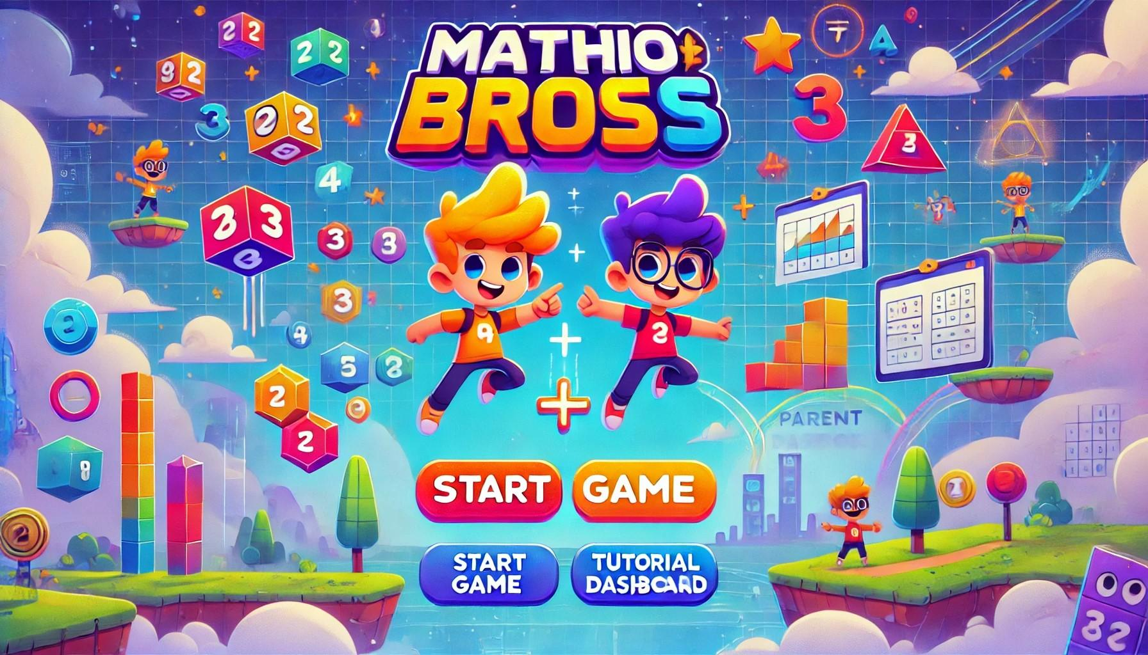

* Gameplay:
  + The game begins with a simple math problem, e.g., “Solve the equation 5 + 3.”
  + The player interacts with objects in the game (e.g., breaking boxes or collecting items) to complete the equation.
  + Once a level is completed, feedback is given to the player regarding performance (time taken, accuracy).
  + As levels progress, the complexity of math problems and time restrictions increases.

An example of how a level will look like :



* Progression:
  + After completing each level, the player’s performance is evaluated and stored.
  + Multiplayer sessions can include collaborative or competitive math challenges.

Each time the player completes a level he will see this screen, and his data about this level will be stored :

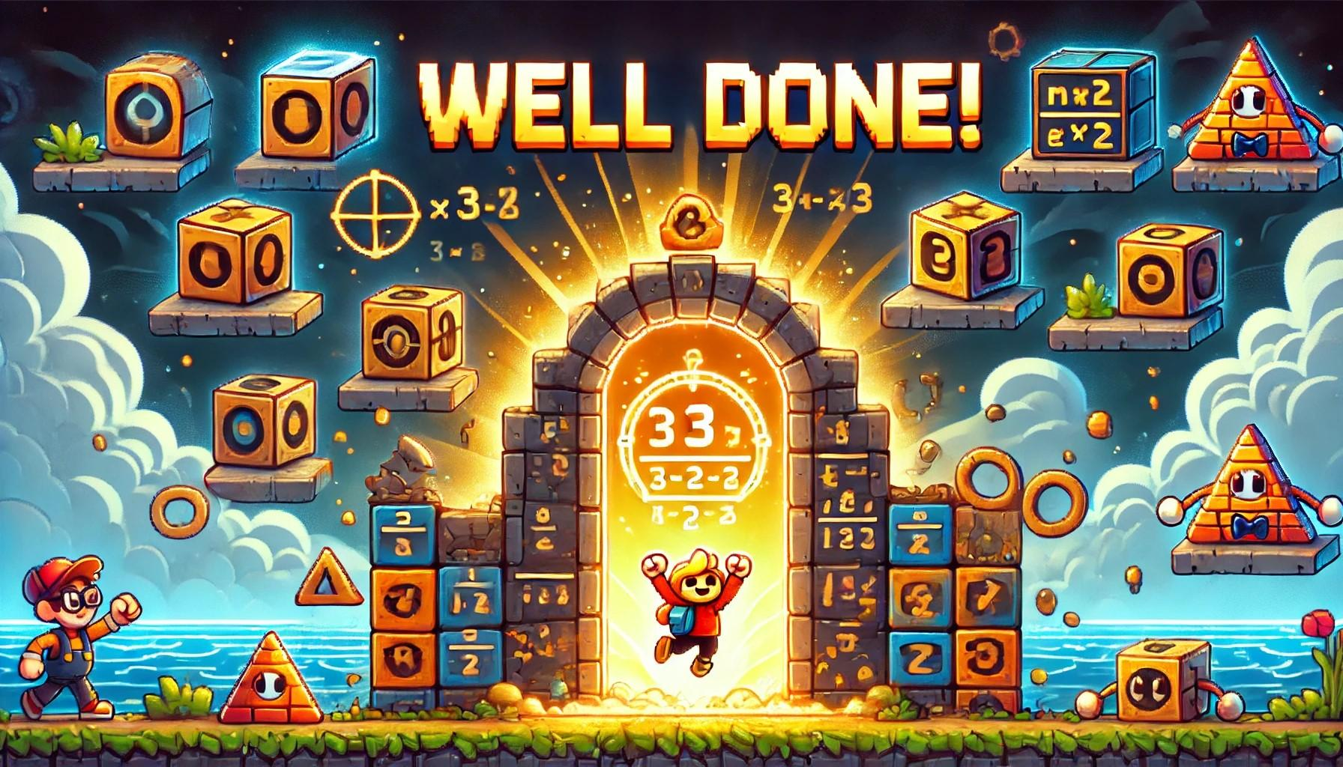

* End Screen:
  + The player can review their performance, retry levels, or proceed to more advanced challenges.

After ending the level and seeing the end level screen, the screen will display this page where he will be able to retry the level go to the next level, or review his performance:

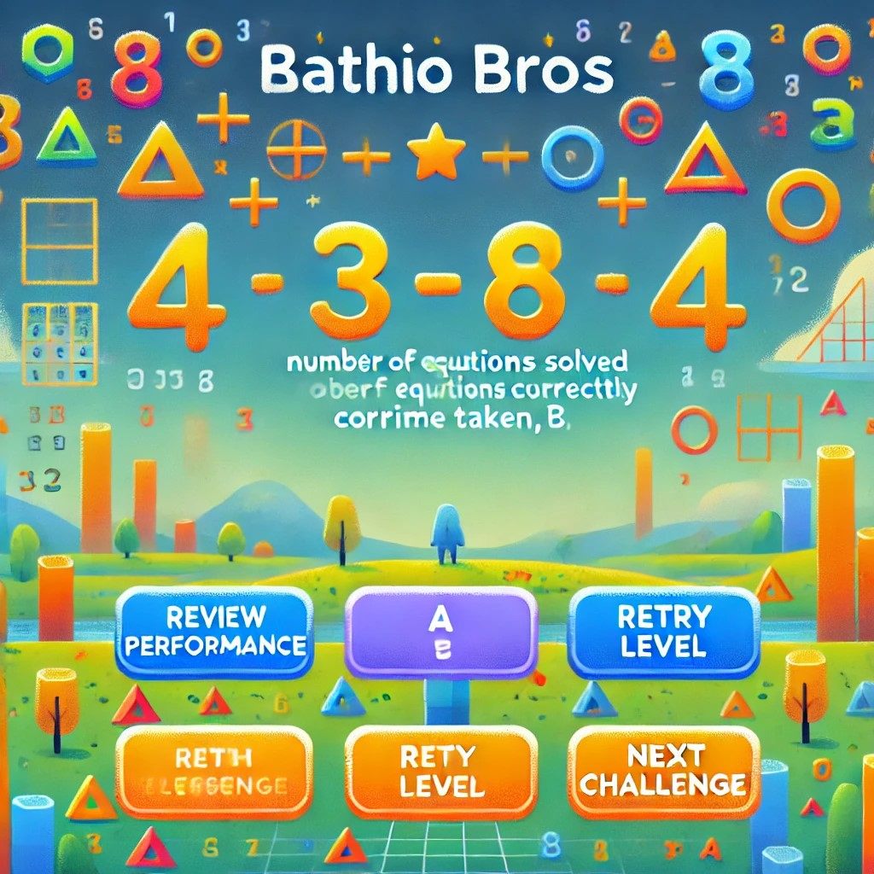

### 6.4 Data Storing and Handling

Mathio Bros. stores data both locally and (in multiplayer) on cloud servers for performance tracking:

* Local Data Storage:
  + Each player’s progress, performance, and settings are saved locally on their device.
  + The data includes:
    - Player name, level, and progress.
    - Time played for each level.
    - Number of attempts per math problem.
* Cloud Storage (for Singleplayer, Multiplayer or Teacher/Parent Dashboard):
  + The game supports multiplayer, game data is stored on cloud servers for single/multiplayer (e.g., Firebase, AWS).
  + This data allows for the tracking of player performance across devices and sessions.
* Data Synchronization:
  + Player progress and game performance are regularly synchronized with the cloud, ensuring that data is consistent across multiple sessions, and allowing for parent/teacher oversight in the case of children players.

### 6.5 Diagrams

#### Use Case Diagram:

This diagram illustrates the interactions between the user (player) and the game system, including multiplayer functionality and the teacher/parent dashboard.

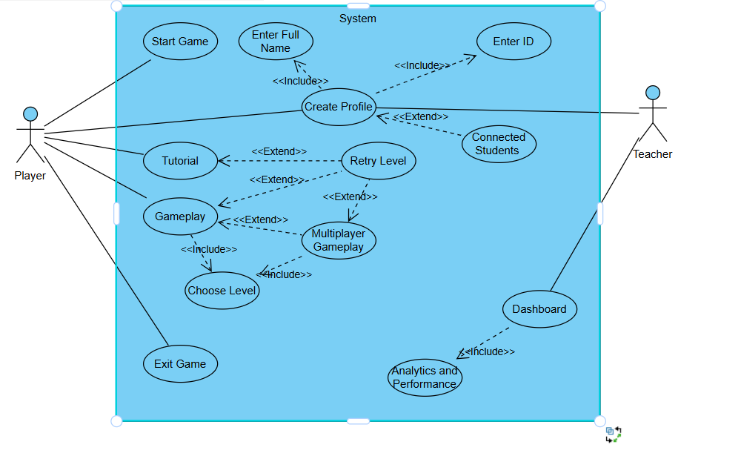

#### Sequence Diagram:

The following diagram shows how the game processes a player’s interaction:

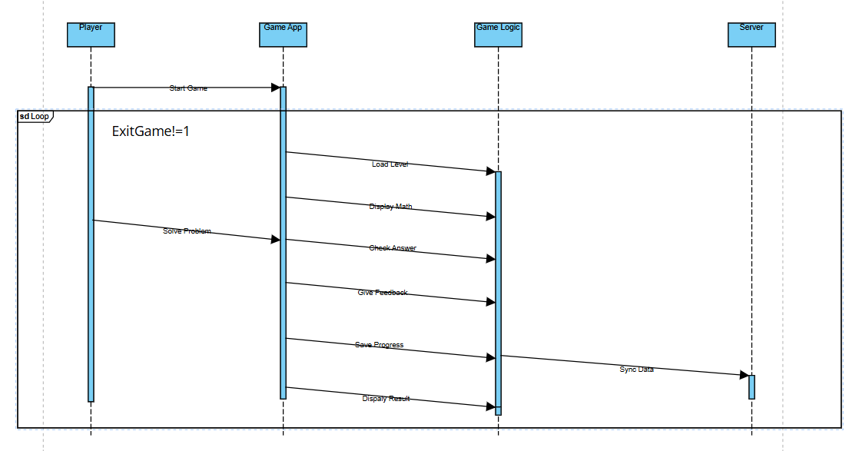

#### Activity Diagram:

This activity diagram shows the full flow of the game from start to finish. 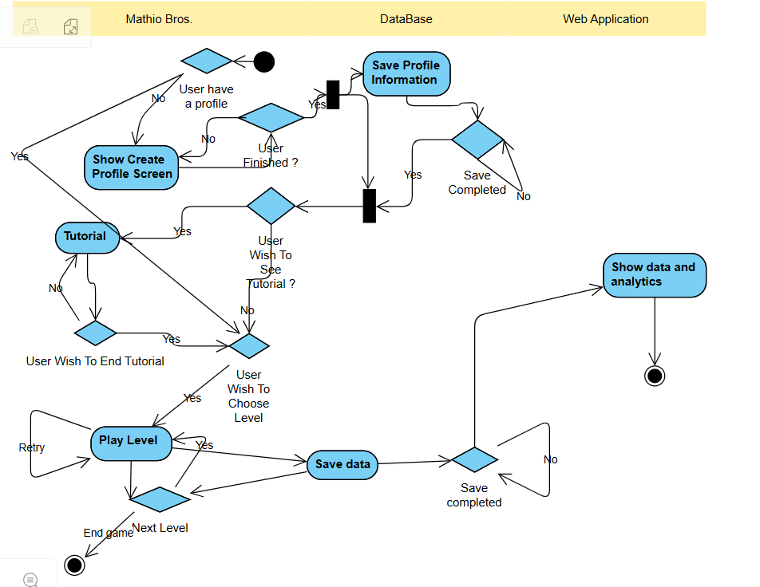

### 6.6 Web Application

Mathio Bros. will include an easy-to-use web-based application to support supervision and provide detailed analytics. This web app will allow parents, teachers, and instructors to monitor student progress, review performance metrics, and intuitively analyze gameplay data.

The web application will be built using the latest technologies for optimal performance and user experience. We will use:

* Next.js: A powerful framework for building scalable web applications, offering seamless front-to-back functionality.
* React.js: A component-based library to ensure modular and efficient UI development.
* Material-UI: A comprehensive UI framework to deliver a polished and user-friendly interface.
* Recharts: A library dedicated to creating clear and visually appealing data visualizations for presenting analytics.

### Web App Pages

#### Home Page

The web app's index page provides an overview of gameplay and learning progress. It features:

* A summary chart displaying the number of games played and average scores for the current week for each player who played.
* Recent activity logs showing solved levels, challenges attempted, and hints used.
* A database representation of players, highlighting recent progress and their supervising teacher/parent.

Description: This figure shows the home page with a bar chart summarizing weekly activity, a list of recent games, and a table of player details.

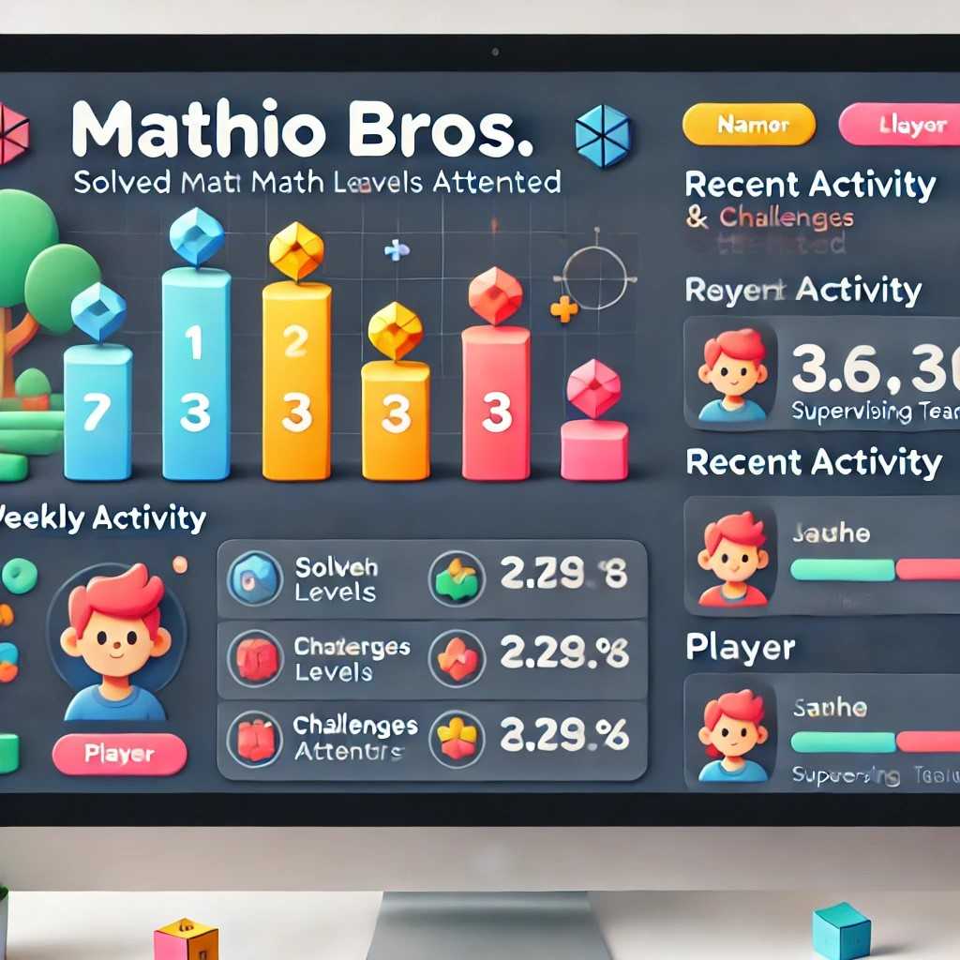

#### Analytics Page

The analytics page allows educators and parents to delve deeper into data. Features include:

* Data Grouping: Group players by age, math skill level, or gameplay frequency.
* Data Comparison: Compare metrics such as accuracy rates, completion times, and challenges solved across different players or groups.
* Dynamic Visualizations: Charts and graphs update based on selected filters to provide clear insights.

Description: This figure showcases the analytics page with interactive filters, a line chart comparing player scores, and a dashboard of comparative metrics.

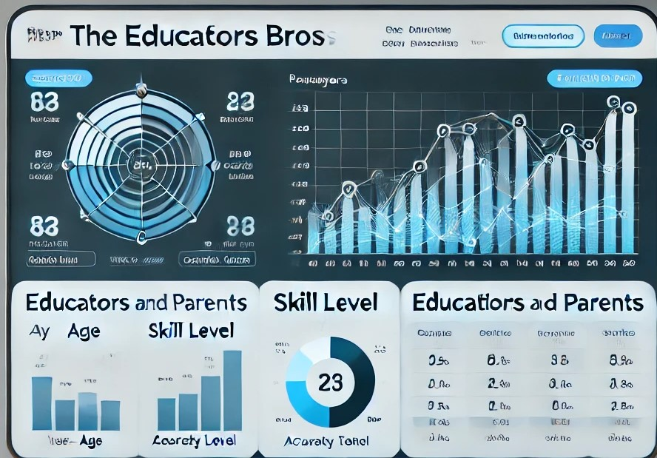

#### Reports Page

The reports page offers detailed insights for individual players. By selecting a player from the database, users can:

* View a summary report of their gameplay sessions.
* Analyze performance trends using visual charts (e.g., accuracy improvement over time).
* Review detailed stats such as hints used, challenges completed, and time spent per level.

Description: This figure depicts the reports page with a summary chart of player performance, a detailed activity log, and an interactive grid for selecting players.

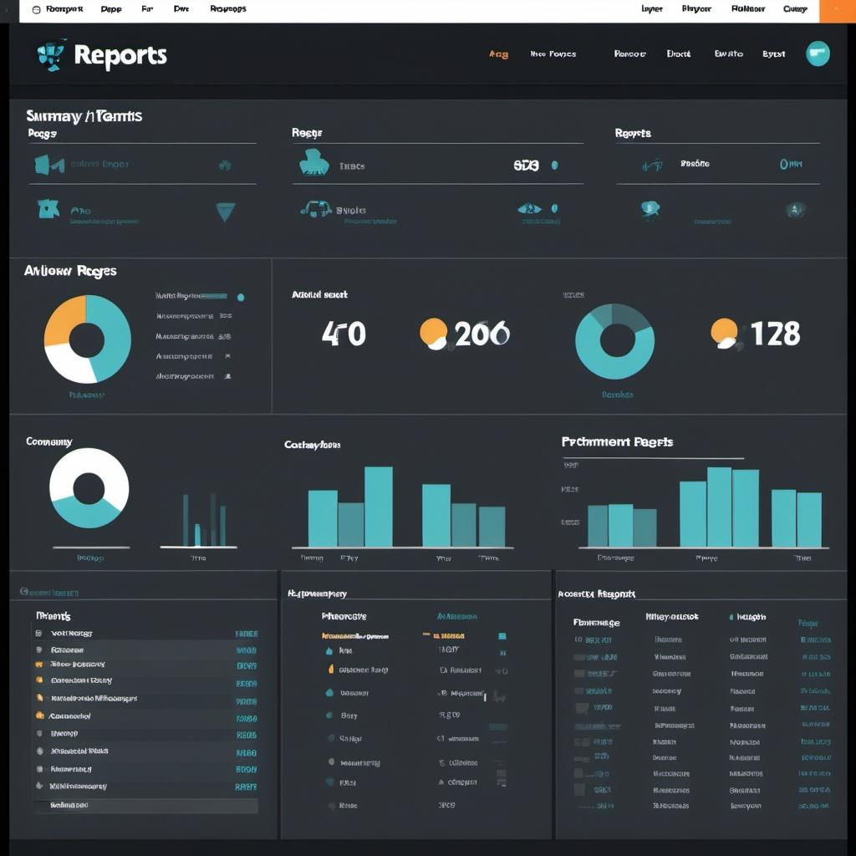

By integrating this web app, Mathio Bros. ensures that learning is not only engaging for students but also trackable and actionable for supervisors. This tool bridges the gap between gameplay and academic oversight, making Mathio Bros. an essential platform for math education.

## 7. Verification and Evaluation

### 7.1 Evaluation

We will evaluate **Mathio Bros.** based on its ability to correctly assess and enhance the user's mathematical skills, track their progress through the game, and provide accurate feedback. The core metrics for evaluation will include:

* Correctness of Gameplay Feedback:
  + The game will be evaluated on its accuracy in providing feedback on math problem-solving. This includes checking whether the player's responses to math challenges are correctly evaluated and whether feedback is timely.
* Game Progression Accuracy:
  + We will assess how well the game tracks the player's progress, ensuring that level difficulty scales appropriately based on the player's performance.
* Engagement and Retention:
  + User engagement will be assessed by how well the game retains players through increasing difficulty, interactivity, and challenge.
* Multiplayer Functionality (if applicable):
  + If multiplayer is included, evaluation will ensure smooth real-time interaction, synchronization of game states, and correct feedback on multiplayer performance.
* User Satisfaction:
  + Feedback from players will be collected through surveys and in-game data to determine satisfaction with the user interface, difficulty levels, and overall gameplay experience.

We aim to provide a fast, engaging, and effective tool for improving math skills while ensuring that it can scale in difficulty for various user levels.

### 7.2 Verification

We will verify the functionality of **Mathio Bros.** through a comprehensive testing process, ensuring that each component works as expected. Testing will be divided into three main categories: **Game Application**, **Data Tracking and Progression**, and **User Interface**.

Testing Plan

Due to the iterative nature of the development process, we will divide testing into the following three sections:

* **Game Application:** Testing the core gameplay mechanics, interactions, and performance.
* **Data Tracking and Progression:** Verifying that the game correctly tracks player performance and progression.
* **User Interface:** Testing the game's interface for usability and responsiveness.

Testing will be done using both **Automated Tests** (such as unit testing) and **Manual QA** (for user experience testing).

### Test Plan

| Test # | Module | Tested Function | Expected Result |
| --- | --- | --- | --- |
| 1 | Game Application | Scene Loading | Fast scene load |
| 2 | Game Application | Steady Framerate | 30 FPS or higher |
| 3 | Game Application | Scene Transitioning | Transition should occur in <2 seconds |
| 4 | Game Application | Correct Input Handling | All player inputs (touch, keyboard, etc.) should be handled as expected |
| 5 | Game Application | Game Mechanics (Math Problem Solving) | The player should be given correct math problems and should receive proper feedback based on their answers |
| 6 | Game Application | Level Progression | Level difficulty should scale appropriately with user performance |
| 7 | Game Application | Multiplayer Functionality (if applicable) | Real-time synchronization of game state in multiplayer mode |
| 8 | Game Application | Character Interaction | Characters and objects should be positioned and behave correctly |
| 9 | Game Application | Data Storage | Player progress and performance data are stored correctly on the device |
| 10 | Data Tracking & Progression | Correct Progression Tracking | Correct progression through levels and challenge difficulty adjustments |
| 11 | Data Tracking & Progression | Player Performance Feedback | Performance feedback should be accurate and updated in real-time |
| 12 | User Interface | UI Load Speed | Main UI should load in <2 seconds |
| 13 | User Interface | Navigation | Smooth and fast navigation between menus and levels |
| 14 | User Interface | UI/UX Design | Simple, user-friendly, and engaging interface for all users, with accessibility features like large text and color contrast for color-blind users |
| 15 | User Interface | Game Screen Display | Main game screen (math problems, player stats) should be clear and legible |
| 16 | User Interface | Dashboard Page | The dashboard should correctly display the player's performance, level progress, and stats |
| 17 | User Interface | End-of-Level Feedback | Clear, accurate feedback after completing each level (e.g., time taken, number of correct answers) |
| 18 | Data Tracking & Progression | Progress Sync Across Devices | Player progress should sync correctly between devices if applicable (in case of multi-device use) |

### 7.3 Testing Frameworks

* **Game Application Testing:**Unity Test Framework for unit tests (to ensure the core mechanics are working), with manual QA for user interaction and gameplay testing.
* **Data Tracking & Progression Testing:**Manual testing of gameplay progression, ensuring the math problem difficulty adjusts based on player performance. We will also verify the storage of player data locally and its accuracy.
* **User Interface Testing:**Jest for unit tests, along with Selenium for end-to-end testing of interface responsiveness and navigation.

## 8. References

[1] Saligumba, I. P., and D. Tan. "Gradual release of responsibility instructional model: Its effects on students’ mathematics performance and self-efficacy." International Journal of Scientific & Technology Research 7.8 (2018): 276-291. [link](https://www.researchgate.net/profile/Denis-Tan/publication/327156345_Gradual_Release_Of_Responsibility_Instructional_Model_Its_Effects_On_Students'_Mathematics_Performance_And_Self-Efficacy/links/5b7d4fd0a6fdcc5f8b5b4813/Gradual-Release-Of-Responsibility-Instructional-Model-Its-Effects-On-Students-Mathematics-Performance-And-Self-Efficacy.pdf)

[2] Molin, Gerhard. "The role of the teacher in game-based learning: A review and outlook." Serious Games and Edutainment Applications: Volume II (2017): 649-674. [link](https://link.springer.com/chapter/10.1007/978-3-319-51645-5_28)

[3] Chan, Liew Lee, and Noraini Idris. "Cooperative learning in mathematics education." International Journal of Academic Research in Business and Social Sciences 7.3 (2017): 539-553. [link](https://ideas.repec.org/a/hur/ijarbs/v7y2017i3p539-553.html)

[4] Cresswell, Clio, and Craig P. Speelman. "Does mathematics training lead to better logical thinking and reasoning? A cross-sectional assessment from students to professors." PloS one 15.7 (2020): e0236153.

[5] Chen, Lang, et al. "Positive attitude toward math supports early academic success: Behavioral evidence and neurocognitive mechanisms." Psychological science 29.3 (2018): 390-402.

[6] Prensky, Marc. "Digital game-based learning." Computers in entertainment (CIE) 1.1 (2003): 21-21.

[7] Gee, James Paul. "What video games have to teach us about learning and literacy." *Computers in entertainment (CIE)* 1.1 (2003): 20-20.

[8] Shute, Valerie J. "Focus on formative feedback." *Review of educational research* 78.1 (2008): 153-189.

[9] Deterding, Sebastian, et al. "From game design elements to gamefulness: defining" gamification"." *Proceedings of the 15th international academic MindTrek conference: Envisioning future media environments*. 2011.

[10] Maloney, Erin A., and Sian L. Beilock. "Math anxiety: Who has it, why it develops, and how to guard against it." *Trends in cognitive sciences* 16.8 (2012): 404-406.

[11] Hattie, John, and Helen Timperley. "The power of feedback." *Review of educational research* 77.1 (2007): 81-112.

[12] Black, Paul, and Dylan Wiliam. "Assessment and classroom learning." *Assessment in Education: principles, policy & practice* 5.1 (1998): 7-74.

[13] Tomlinson, Carol Ann. The differentiated classroom: Responding to the needs of all learners. Ascd, 2014.

[14] Boaler, Jo. Mathematical mindsets: Unleashing students' potential through creative mathematics, inspiring messages and innovative teaching. John Wiley & Sons, 2022.

[15] Johnson, David W., and Roger T. Johnson. Learning together and alone: Cooperative, competitive, and individualistic learning. Prentice-Hall, Inc, 1987.

[16] Webb, Noreen M. "Task-related verbal interaction and mathematics learning in small groups." *Journal for research in mathematics education* 22.5 (1991): 366-389.

1. <https://www.coolmathgames.com/>
2. <https://itch.io/games/genre-platformer/tag-math>
3. <https://mathsframe.co.uk/>
4. <https://store.steampowered.com/app/3018890/The_ultimate_Math_teaching_game/>
5. <https://www.superprof.co.uk/blog/maths-and-the-modern-world/>
6. <https://www.naeyc.org/positionstatements/mathematics>
7. <https://www.spacefoundation.org/2023/10/05/critical-thinking-steam/>
8. <https://readingandmath.org/early-math-exposure-you-can-help/>